>> Diff between inline and block element (div and span)
>> diff between Semantic Elements and non Semantic Elements
>> Semantic Elements
>clearly describe their meaning and purpose to both the browser and developers
>improve readability, SEO, and accessibility
This html 5 semantic elements
• <header> → Represents the header section of a page.
• <article> → Represents an article or self-contained content.
• <section> → Represents a thematic grouping of content.
• <footer> → Represents the footer section.
• <nav> → Represents navigation links.

>> Non-Semantic Elements
- These elements do not describe their content; they are just containers.
- • <div> → Generic container.
- • <span> → Inline container

>> <!DOCTYPE>
<!DOCTYPE> in HTML is a declaration that tells the browser which version of HTML the page is written in. It is placed at the very top of an HTML document, before the <html> tag.
>>META
the <meta> tag is used to provide metadata about the web page. Metadata means data about data—information that describes the page but is not displayed directly on the page.
>> Void elements
Void elements in HTML are elements that cannot have any content or closing tag. They are self-contained and self-closing by nature.
• <br> → Line break
• <img> → Image
• <hr> → Horizontal rule

>> difference between <script>, <head>, and <body> in HTML:
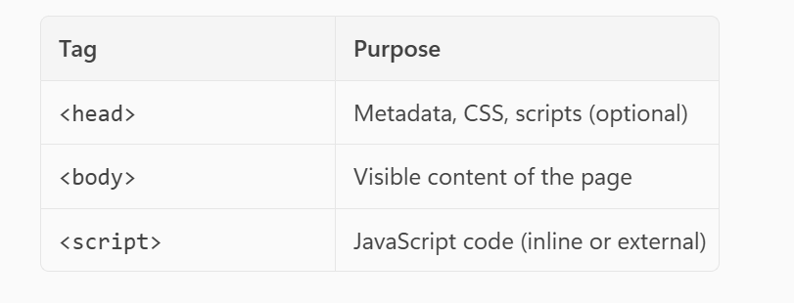
>> Why Web Workers?
- Normally, JavaScript runs on the main thread.
- If you do something heavy (like processing large data), the UI can freeze.
- Web Workers solve this by running code in a background thread, so the UI stays smooth.
>> data-*
The data-* attribute in HTML is used to store custom data on HTML elements.
• To store extra information about an element that can be accessed via JavaScript.
• Useful for:
- Passing dynamic data to scripts.
- Storing IDs, roles, or configuration values.
- Avoiding misuse of class or id for data storage.
>> caching mechanism
HTML caching mechanism refers to how browsers and servers store resources (HTML, CSS, JS, images) to improve performance and reduce load times. Instead of downloading everything on every request, browsers use cached copies when possible.
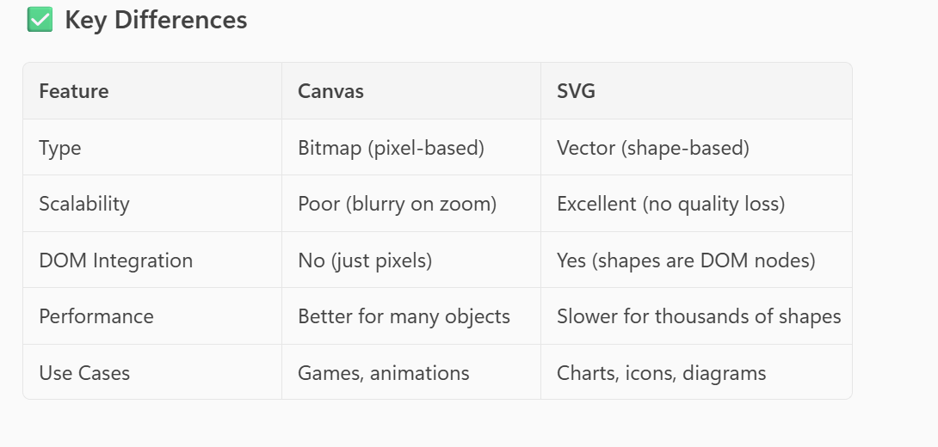

CSS
>> CSS Boxmodel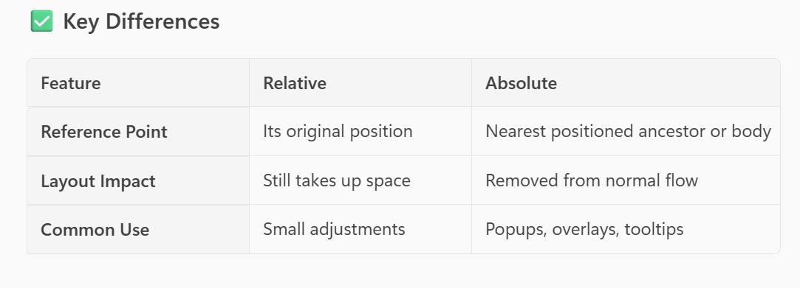
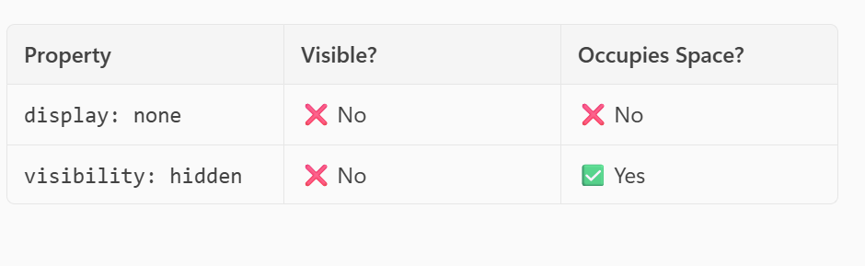

>> CSS Specificity
CSS Specificity determines which CSS rule is applied when multiple rules target the same element. It’s basically a priority system for CSS selectors.
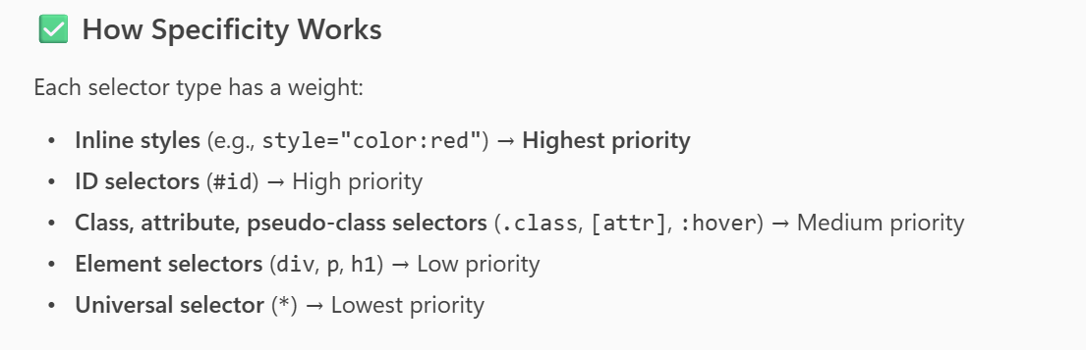
>> !importent
>> z-index
>> Stacking context in CSS
Stacking context in CSS refers to the way elements are layered (stacked) along the z-axis when they overlap. It determines which element appears on top of others.
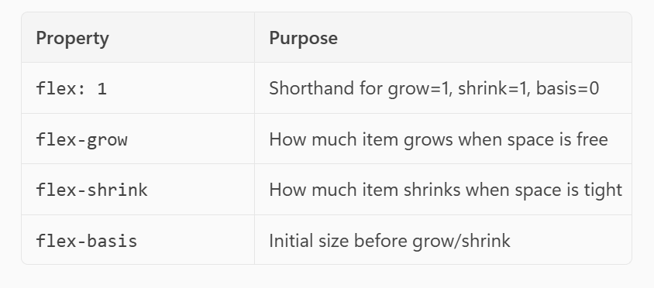
>>
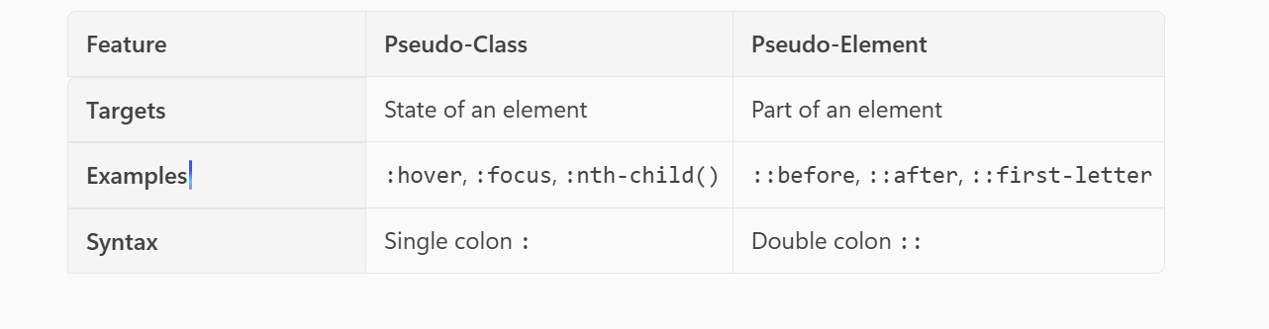
>> universal selector (*)
>>:root selector
The :root selector in CSS is a pseudo-class that targets the root element of the document, which is usually the <html> element in an HTML page.

>>CSS sprites are a technique used to combine multiple images into a single image file and then display only a portion of that image using CSS. This is mainly done to reduce HTTP requests and improve page load performance.
>>
The Shadow DOM is a key concept in Web Components that allows you to create encapsulated DOM trees with their own scoped CSS and markup, separate from the main document DOM. This helps avoid style conflicts and makes components truly reusable.

>>SCSS
>>Sass stands for Syntactically Awesome Stylesheets. It’s a CSS preprocessor that adds powerful features to CSS, making it easier to write, maintain, and scale styles for large projects.

• Cleaner and more organized code
• Reusable styles → reduces duplication
• Easier maintenance for large projects

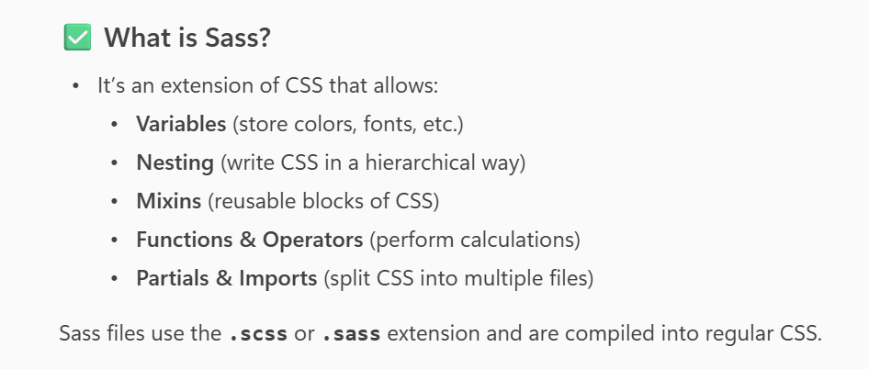
// Define a variable
$primary-color: #3498db;

// Nesting and using variable
nav {
background-color: $primary-color;

ul {
list-style: none;

li {
display: inline-block;
}
}
}

// Variables
$primary-color: #3498db;
$secondary-color: #2ecc71;
$font-stack: 'Roboto', sans-serif;

// Mixin for reusable button styles
@mixin button-style($bg-color) {
background-color: $bg-color;
color: #fff;
padding: 10px 20px;
border: none;
border-radius: 5px;
cursor: pointer;
font-size: 16px;

&:hover {
opacity: 0.8;
}
}

// Global styles
body {
font-family: $font-stack;
margin: 0;
padding: 0;
background-color: #f4f4f4;

header {
background-color: $primary-color;
color: white;
text-align: center;
padding: 20px;

h1 {
margin: 0;
}
}

main {
padding: 20px;

.btn-primary {
@include button-style($primary-color);
}

.btn-secondary {
@include button-style($secondary-color);
}
}
}

✅ What is @mixin?
- A mixin is like a function for CSS.
- It lets you define a group of styles that can be reused anywhere.
- You can also pass parameters to make it dynamic.

✅ What is @include?
- @include is used to apply a mixin to a selector.
- It inserts the styles defined in the mixin into that selector.
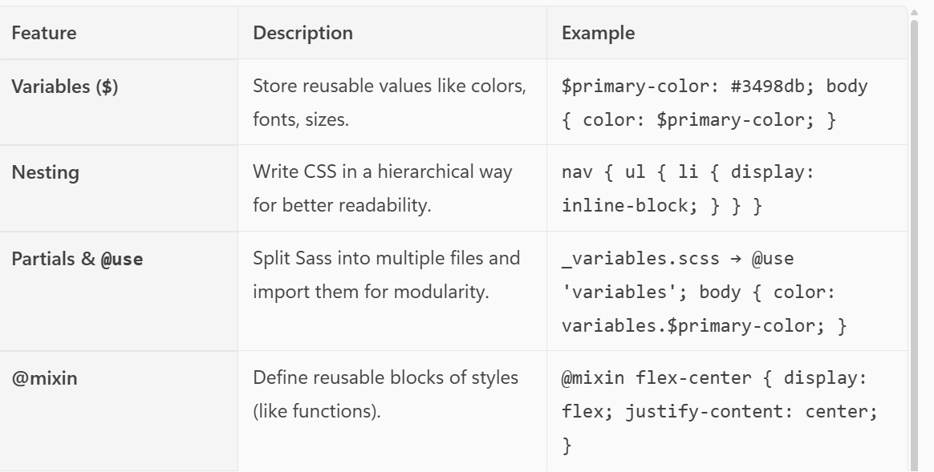
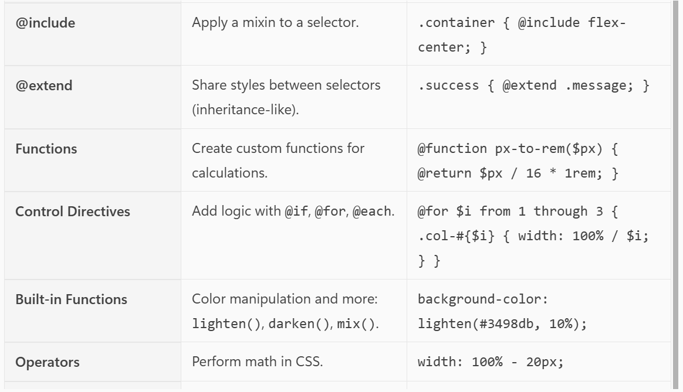
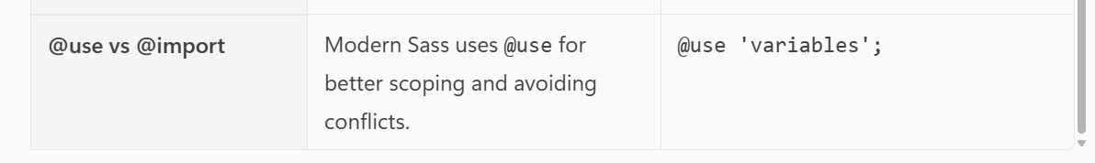

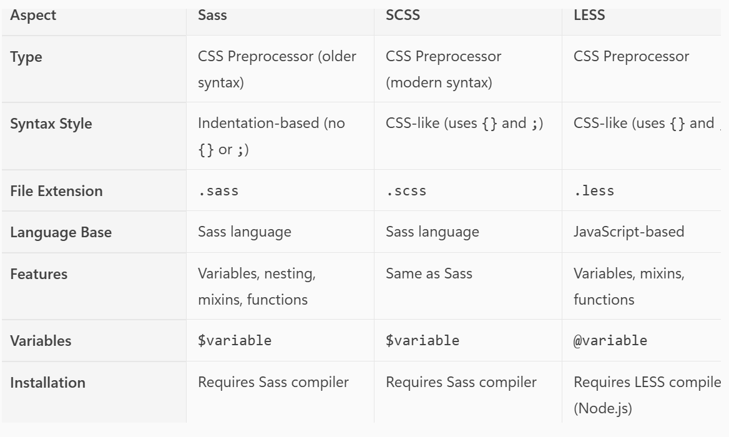
>>Unites
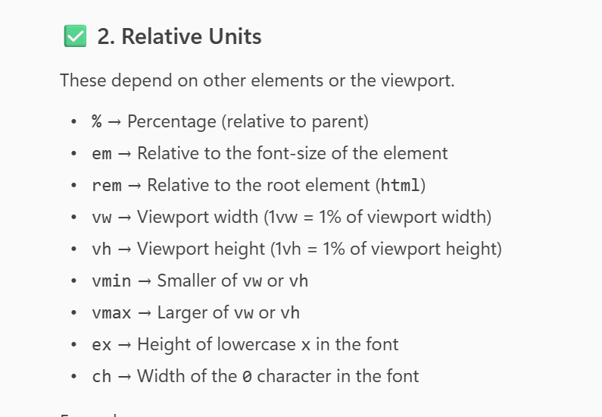
Semantic element example
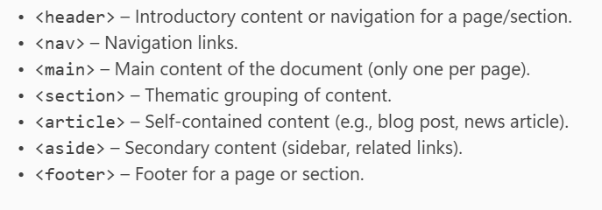
<body>
<header>
<h1>My Website</h1>
<nav>
#Home</a> | #About</a>
</nav>
</header>

<main>

<section>
<h2>Benefits</h2>
<ul>
<li>Better SEO</li>
<li>Improved Accessibility</li>
<li>Cleaner Code</li>
</ul>
</section>

<article>
<h1>Understanding Semantic HTML</h1>
<p>Semantic HTML improves accessibility and SEO by giving meaning to elements.</p>
</article>
</main>

<aside>
<h2>Related Links</h2>
<ul>
<li>#HTML Basics</a></li>
<li>#CSS Layouts</a></li>
<li>#Accessibility Tips</a></li>
</ul>
</aside>

<footer>
<p>&copy; 2025 My Website</p>
</footer>
</body>

